Before install the program, you should have the below programs on your PC.

1. Microsoft SQL Server 2014_Express

2. SQL Management Studio

3. SQL Local DB

After that you can install the program and follow the steps before open the program:

1. Open **Sql Server Configuration Manager** --> **SQL Server Network configuration** --> **Protocols for <(INSTANCE)>** --> **TCP/IP** (double click on it).

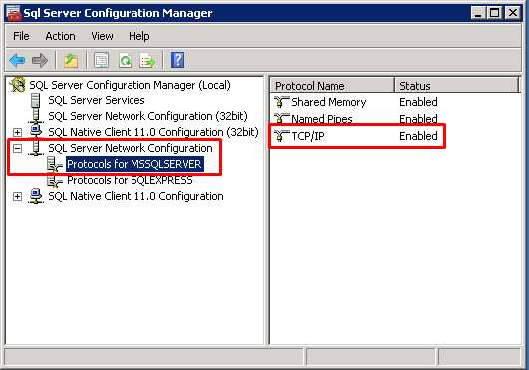

2. Select --> **IP Addresses(Tab)**.

3. Change the (Active & the Enable) to be Yes, for IP1 & IP2

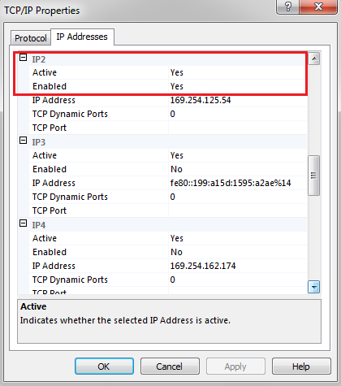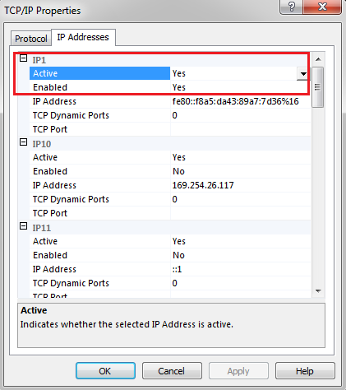

4. Return to **Sql Server Configuration Manager** --> and select **SQL Server Services**

**And insure to change the state for (SQL SERVER & SQL SERVER Browser) to be Running.**

**And the Start Mode to Automatic.**

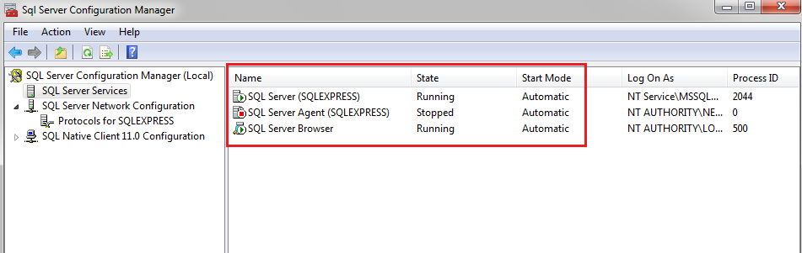

5.  Press Win+R and enter **services.msc**.

6. Now restart **SQL Server <(INSTANCE)>**.

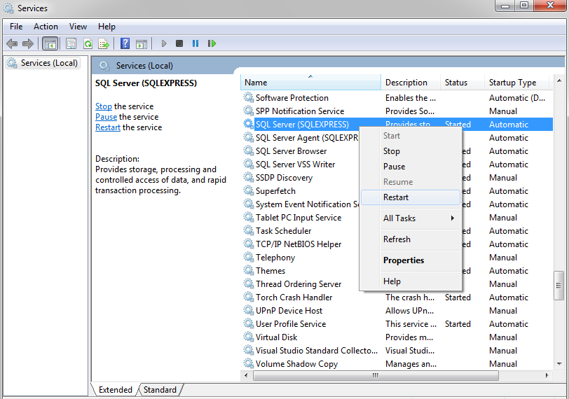

7. Open the Folder where the program installed in **>-- C:\Program Files**\

8. **Right Click** on the File name **>-- Database1 >-- Properties >-- Security Tab**

9. Select your computer user from **Group or User names >-- Edit >-- Select the User again >-- Check for Full Control in permission for Users >-- Apply >-- OK**

10. **Right Click** on the File name **>-- Database1_log >-- Properties >-- Security Tab**

**11.** Select your computer user from **Group or User names >-- Edit >-- Select the User again >-- Check for Full Control in permission for Users >-- Apply >-- OK**

